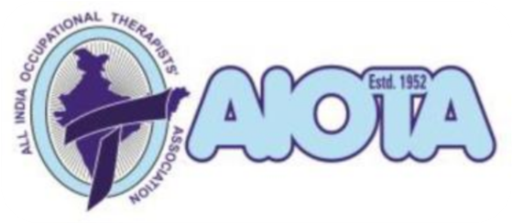
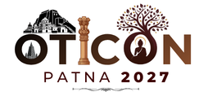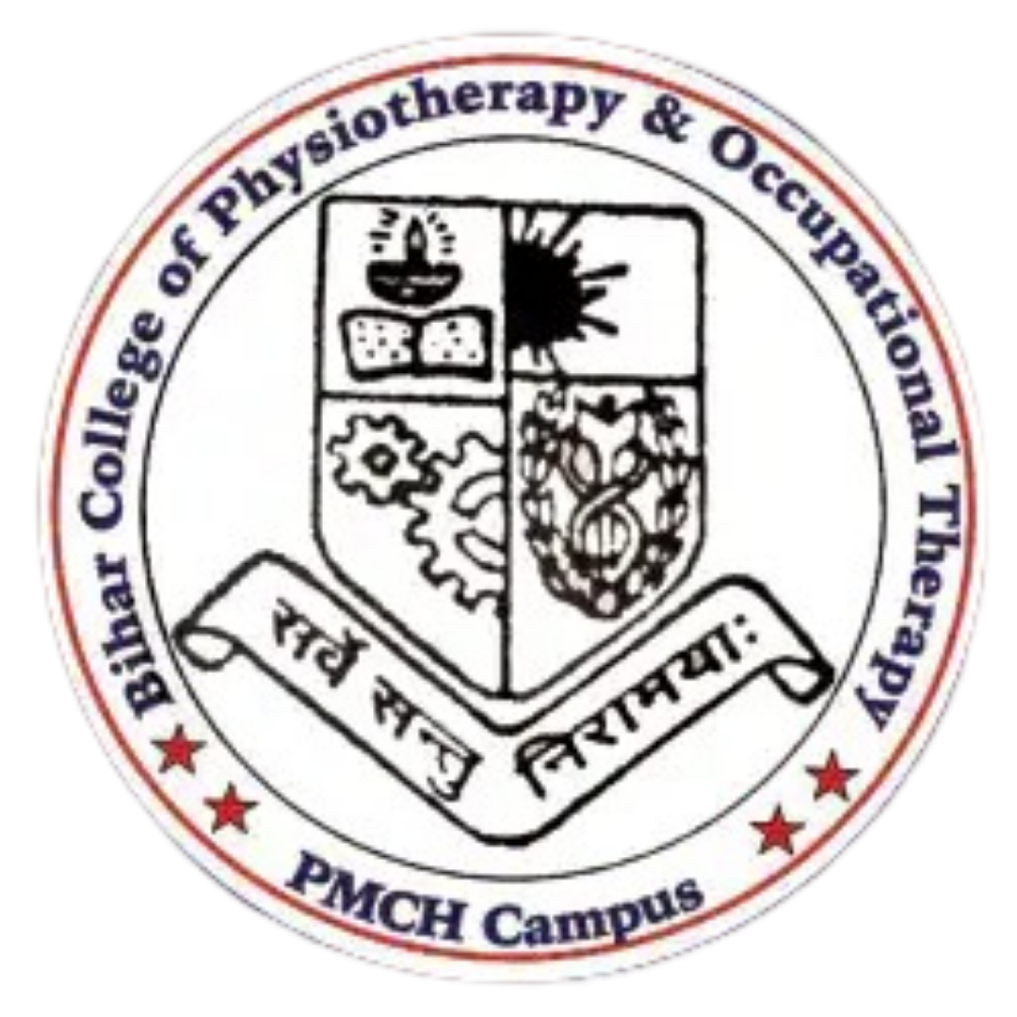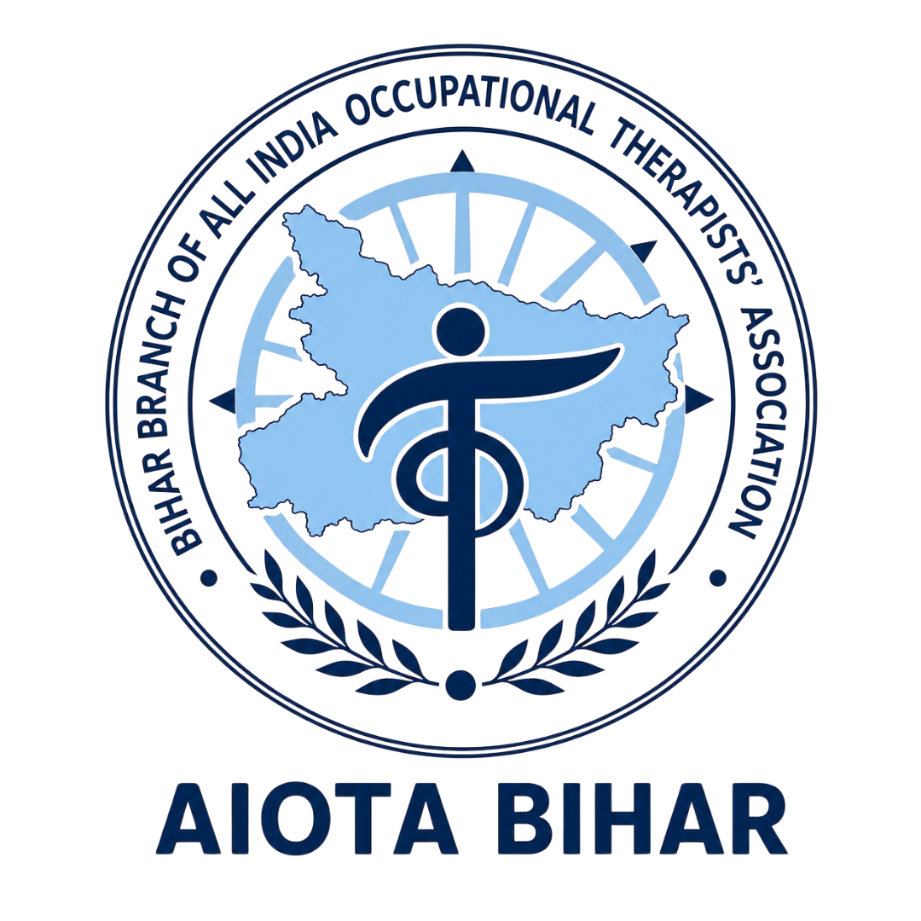

OTICON-2027
The 64th Annual National Conference of AIOTA
Theme: Occupational Therapy & Health: From Prevention to Occupational Justice
5th, 6th & 7th February 2027 | Gyan Bhawan, West Gandhi Maidan, Patna

STUDENTS' SCIENTIFIC PROGRAM REGISTRATION FORM
(Please use block letters only)
NAME OF THE INSTITUTE:
POSTAL ADDRESS:
E-MAIL:
PHONE & MOBILE NUMBER:

Name of the Event: Please tick (✓) anyone. Apply separately for different events.
☐ AIOTA Trophy for Best Poster | ☐ AIOTA Trophy for Best Street Play
☐ AIOTA Trophy for Best Innovative Technology | ☐ OMG Provo Award for Humorous Poster
☐ Best Student Delegate OTICON 2027 Award (Karnataka Branch of AIOTA) | ☐ Gold Medal Award for Best OT Graduates of 2026
Nature of Participation: Please tick (✓) any one | ☐ Non-Competitive Category  ☐ Competitive Category

Sl.No. | Name of the Student  Member | AIOTA Student Member  Number | OTICON 2027 Registration  Number
1.
2.
3.
4.
5.
6.
7.
8.
9.
10.
Name of the Student Coordinator:
Contact Number:

NOTE:
- Name of the Participants (AIOTA Student Membership is Mandatory)
- Maximum of 10 undergraduate students from each participating institution for Poster, Innovative Technology & Street Play.
- Maximum of 2 undergraduate students per institution for Best Student Delegate/OMG Poster.
- Maximum two candidates from each College/Institute, subject to eligibility criteria, will be permitted to appear the examination for the Gold Medal award for Best OT Graduate 2026.

Declaration by Participants
☐ We hereby declare that the information provided above is true to the best of our knowledge. We understand that only AIOTA student members from recognized colleges are eligible for participation. All content submitted (poster, tech, etc.) is original work.
☐ We grant permission to the OTICON 2027 Scientific Committee to use submitted materials, including posters, photos, and names, for the purpose of documentation, publication, and promotion of AIOTA activities.
☐ Scanned copy of the duly filled and signed Form shall be submitted via email only to the Chairperson, Scientific Program Committee, OTICON 2027, on or before 20th December, 2026; without which participation will not be accepted.

Faculty Coordinator Email ID (Official College ID only): ____________________________

Date:

Name & Signature
Head of the Institute with Official Seal

E-mail this form to:
Dr. Santosh Kumar
Chairperson, Scientific Program Committee, OTICON 2027
Director, Chetna Foundation

Email: scientificchairperson.oticon27@gmail.com
Mobile No: +91-9911338017
Dept. of Occupational Therapy, BCPO, Patna, Bihar – 800020
Website: www.aiotabihar.com

